Angular 2 Course Structure

Duration: 3 days

S#

Session Title

Session Sub Topics

Introduction to front end frameworks and SPA,

history about Angular, Intro to Angular 2, Tech

1

Introduction to SPA &

Angular 2

Stack supporting Angular 2, Dev Environment

setup, Developing Hello World Example for

Angular 2

Intro to ES6 - Scoping, Destructuring, Promises,

Arrow Functions, Sets & Maps, Rest Operators &

Typescript - Data Types, Interfaces, Classes,

Decorators

Angular 2 Seed, Cloning & Running Seed

Project using NPM Scripts, Bootstrapping

Angular App, Recommended Project Structure,

Angular Modules, Library Modules, Basics of a

Component

Interpolation, Template Expressions, Template

Statements, Binding Syntax, Property Binding,

4

Angular Template Syntax,

Inbuilt Directives

Attribute Bindings, Event Binding, Local

Template Variables, \* and <template>, Built-in-

Directives - NgClass, NgStyle, NgIf, NgSwitch

Difference in Event Binding & Property Binding,

Two way data binding with ngModel, Form

5

Data Binding, Forms in

Angular 2

Controls in Angular 2 - ngControl, Template

Driven, CSS for Forms, Error & Validation

Handling, ngForm , ngSubmit

What is DI ?, Angular DI, Configuring Injector,

6

Dependency Injection in

Angular 2

Injectable Decorators, Dependency Injection

Tokens, DI without Types, Examples

2

Typescript, ES6

3

Seed Project, Bootstrapping,

Project Structure, Angular

Module, Component Basics

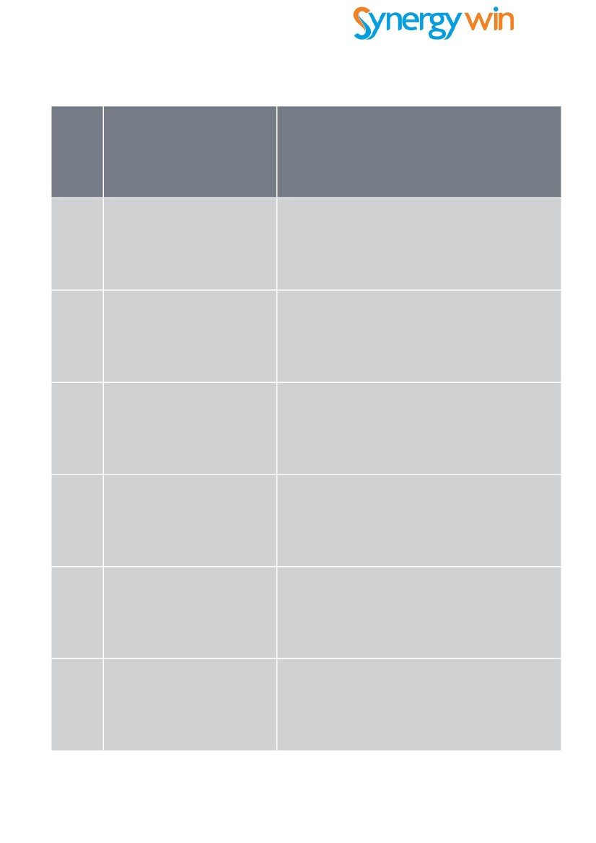

S#

Session Title

Session Sub Topics

7

Components in Details

Components, Meta Data for Classes - Selectors,

View Providers, Styles, Encapsulation,

Templates, Component Availability, Annotations,

Event Delegation, ViewChildren, Content

Children

Directives - Attribute / Structural, Host, Web

Components Basic, Export As, Lifecycle, Inputs,

Outputs

8

Directives in Details

9

Pipes

Basic Pipes, Chaining Pipes, Parameters in

Pipes, Async Pipes, Built In Pipes - Date, Slice,

Decimal, Percent, Currency, Json, Lowercase,

Uppercase

Intro to Router, Syntax for Routes, Configuration,

Navigation, Lifecycle, Child Router, Query

Parameters, URL Style/HTML5 Mode, Linker

Route Parameters

10

Routing & Navigation

11

Http Client

Http Client Example, HTTP Get, Post Methods,

Promises, Transforming Data, JSONP, Custom

Headers, Query String Parameters, Intro to RxJS

12

Services & Providers

Intro to Services in Angular 2, Custom Services,

Providers Overview, Custom Providers, Simple

Service Example



S#

Session Title

Session Sub Topics

13

Lifecycle Hooks

Component Lifecycle, Methods - OnInit,

OnDestroy, DoCheck, OnChanges,

AfterContentInit, AfterContentChecked,

AfterViewInit

14

Events in Angular

Event Emitter Class, Emit Method, Next Method,

Subscribe Method

15

Observables, State Management with

Data & State Management

Observables, RxJS in Detail, ngRedux

16

Migrating Angular 1 to 2

Code Changes, Upgrade Adapter, Hybrid App

Angular 1 & 2, Upgrade Controllers

17

Performance Considerations,

Change Detection

Performance Considerations, Change Detection

system, Change Detection Strategies,

Bypassing Components

Unit Testing, Technologies - Jasmine, Mock

18 Testing Angular 2 Apps Dependencies, Testing Components, End to End

Tests, Performance Tests

